I would like St. Bonaventure’s KidZone Playscheme to look after my child/ren

Name(s), Age and School……………………………………………………………………………………………………………

…………………………………………………………………………………………………………………………………………..

Costs | Full Day  8:30-17:45 | Short Day  10:00 – 16:00 | Half Day  8:30-13:00 or 13:00-17:45
 | £23 | £16 | £12

Workshop  Costs | Multi-Sport  Premier Sport | Zoolab | Nerf Combat  Premier Sport | Bouncy Castle  Per Day | Yoga  Big Kid Yoga
 | £3 | £5 | £3 | £3 | £5
 | 27th July | 31st of July | 10th of August | 25th/26th of July | 16th of August
 | 13:00-16:00 | 13:00-14:00 | 13:00-16:00 | All day | 13:30-14:30

Booking: Please select sessions and workshops by ticking the relevant boxes.

Week 1: Monday 24th to Friday 28th of July 2017

Day | Full Day | Short Day | Half Day  AM | Half Day PM | Bouncy Castle | Multi-Sport Workshop  Premier Sport
Monday  24th |  |  |  |  | N-A | N-A
Tuesday  25th |  |  |  |  |  | N-A
Wednesday  26th |  |  |  |  |  | N-A
Thursday  27th |  |  |  |  | N-A
Friday  28th |  |  |  |  | N-A | N-A

Week 2: Monday 31st of July to Friday 4th of August 2017

Day | Full Day | Short Day | Half Day  AM | Half Day PM | Zoolab  Workshop
Monday
31st
Tuesday  1st |  |  |  |  | N-A
Wednesday  2nd |  |  |  |  | N-A
Thursday  3rd |  |  |  |  | N-A
Friday  4th |  |  |  |  | N-A

Week 3: Monday 7th to Friday 11th of August 2017

Day | Full Day | Short Day | Half Day  AM | Half Day PM | Nerf Combat  Premier Sport
Monday  7th |  |  |  |  | N-A
Tuesday  8th |  |  |  |  | N-A
Wednesday  9th |  |  |  |  | N-A
Thursday
10th
Friday  11th |  |  |  |  | N-A

Week 4: Monday 14th to Friday 18th of August 2017

Day | Full Day | Short Day | Half Day  AM | Half Day PM | Yoga  Big Kid Yoga
Monday  14th |  |  |  |  | N-A
Tuesday  15th |  |  |  |  | N-A
Wednesday
16th
Thursday  17th |  |  |  |  | N-A
Friday  18th |  |  |  |  | N-A

Paying: Total Cost for KidZone

Payment | Cost per booking | Number Booked | Cost of bookings
Full Day | £23
Short Day | £16
Half Day | £12
Workshops | See Above

Payment Method

Please indicate below how you wish to pay.

I will pay via School Gateway / Cheque* / Cash / Voucher

Booking is only accepted with payment.

*Payable to St Bonaventure’s School, please clearly mark the reverse of your cheque with ‘playscheme’ and name of child(ren).

Please note, non-St Bon’s parents must also fill in a KidZone Registration form.

Signed Parent/Carer ………………………………………………….…Date………………………………………………………

KidZone Playscheme Summer Workshops

Zoolab
Zoolab bring the zoo, to the Playscheme. Zoolab specialise in placing a range of small animals into the hands of children. Animals in question range from snakes, spiders, rats and turtles. Children participating in this workshop will sit with the Zoolab team for one hour and be introduced to each animal in turn. Children will have the chance to handle many of the animals themselves and learn about them throughout this hands on, practical session.

When: Monday 31st of July 2017 at 1pm

Cost: £5 per child, maximum of 35 children

http://www.zoolabuk.com/

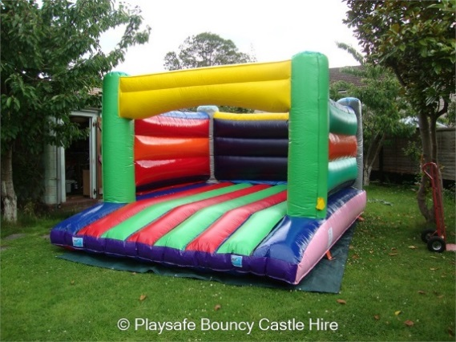

Bouncy Castle
Adults and children alike love bouncy castles, we are therefore super excited to be hosting a bouncy castle across two days at the KidZone Playscheme. Children will have access to the bouncy castle thought the day ensuring they can bounce at their leisure until their heart is content.

When: Tuesday 25th and Wednesday 26th of July

Cost: £3 per child, per day

Multi-Sport Games Workshop
A workshop full of group games and challenges designed to introduce children to the world of sports. Qualified coaches from Premier Sports will lead the children through a series of activities drawing on sports such as Archery, Fencing and Gym amongst others.

When: Thursday 27th of July from 13:00 till 16:00

Cost: £3 per child
https://sport.premier-education.com/

Nerf Combat
Put your NERF skills to the test with the ultimate NERF Activities day. Master the obstacle course or sharpen your skills on the target range whilst gaining as many points as you can for yourself, and for your team. A paint ball esque experience for children of all ages and abilities.

Safety Goggles Provided – Children can bring their own NERF Equipment if they choose.

When: Tuesday 10th of August from 13:00 till 16:00

Cost: £3 per child

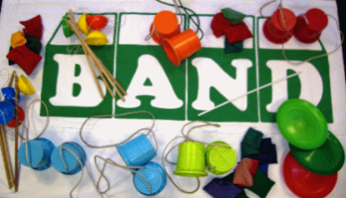

Giant Games
KidZone has teamed up with BAND to offer the children access to a selection of unique resources including giant Jenga and Kerplunk, skittles, swing ball, a crazy gold set, and uni-cycles. These resources will be on offer across the week beginning Monday July 31st and can be accessed free of charge.

When: Week beginning July 31st

Cost: Free

When: Tuesday 16th of August from 13:30 till 14:30

Cost: £5 per child

