Fun Winter Walks
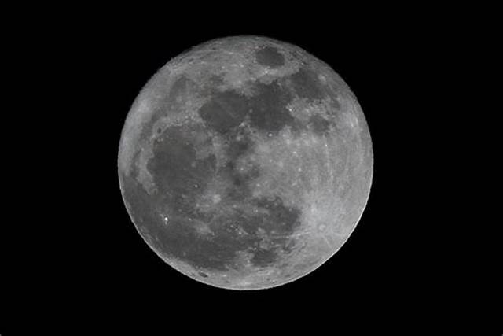
Moon walks
Rather than heading out during the day, go for a walk by moonlight while the days are short and the nights are long. Under a full moon is best if you want to have your path lit but darker nights are great for star-spotting: look out for the Quadrantids meteor shower from the beginning of January and dark skies on February 11 when there will be a New Moon, which means the moon won’t be visible in our night skies. Let your children play with torches when you go out – you’ll be amazed how much fun they can have with a simple beam of light.
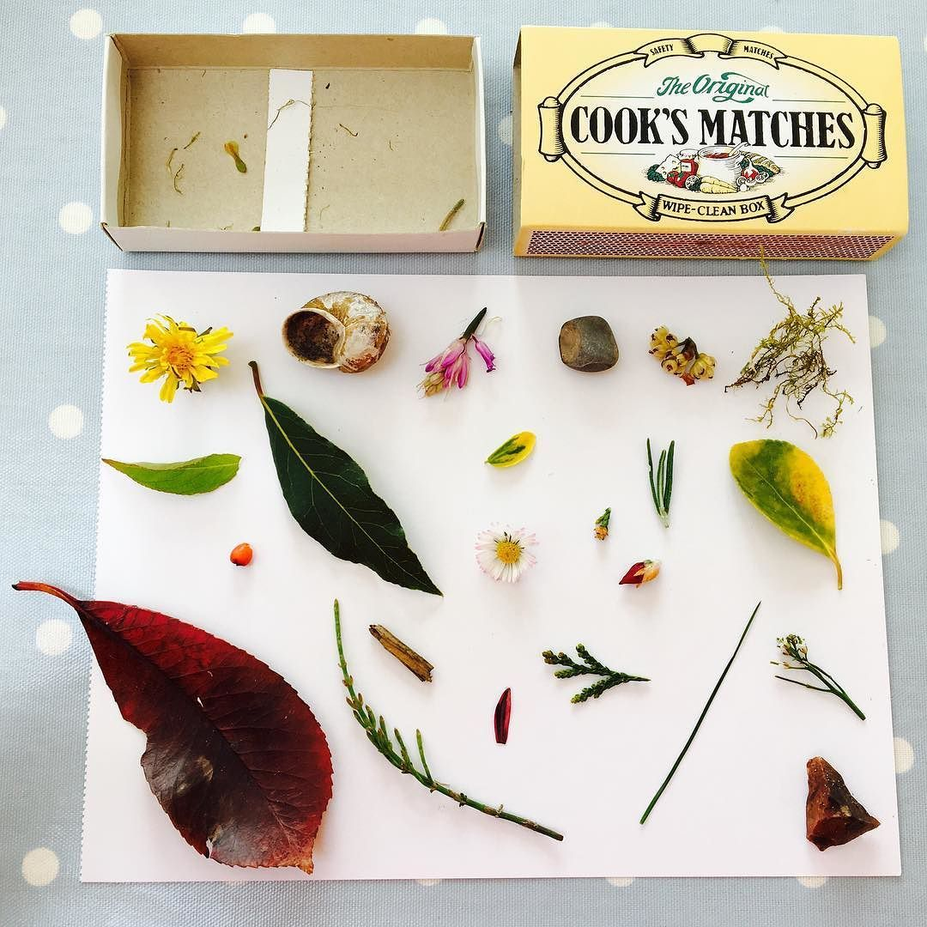
Matchbox museums
A smaller alternative to a nature box, give each child their own empty matchbox and ask them to see how many tiny objects they can fit into it to make their own matchbox museum.
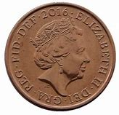
Penny walks
Give your children a penny and ask them to decide whether heads or tails is left or right. Every time you reach a junction, flip the penny and let it decide where you’ll walk next. You may find yourselves discovering some new neighbourhoods (and maybe a few dead ends, but it’s all part of the fun!).
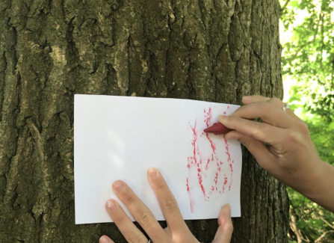
Bark rubbing
You probably did this when you were a child, but have you tried it with your own children? There’s something really satisfying about creating your own impression of a tree trunk by simply placing paper over it and rubbing a wax crayon lengthways over it until the paper is filled. Use lots of different colours for a rainbow effect.
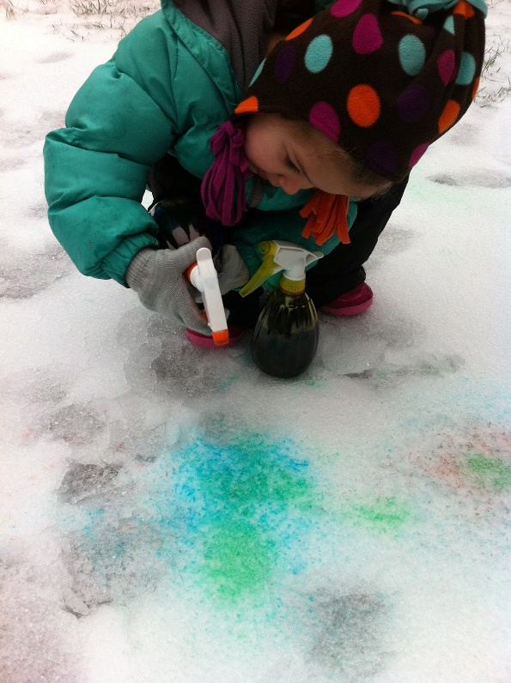
Snow painting
Who says snow has to be white? If there’s enough snow, try making snow paint with spray bottles, food dye and water. Fill spray bottles with water and add food dye (gel dye is brighter). Screw the lid on and shake. To use, hold the nozzle of the bottle a few inches from the snow and spray to create colourful designs that won’t last forever!
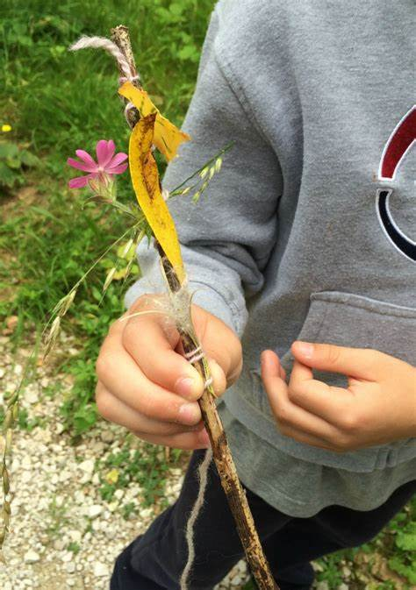
Journey sticks
Journey sticks are a way to create a visual guide to the walk you’ve taken. Pick a stick that is around a foot long and, as you walk, pick up fallen items that you see such as leaves, twigs, flowers, berries and so on and wind them on to the stick using wool or string. For an easier method, use a strip of cardboard with double-sided sticky tape on it which you can stick items to.
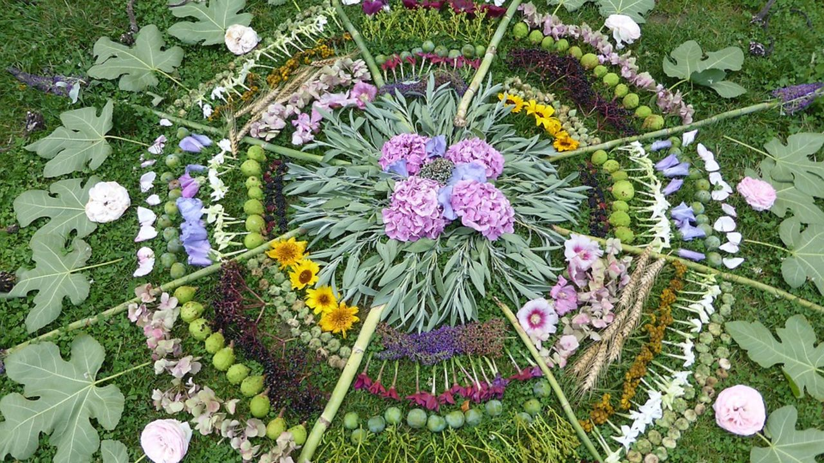
Nature mandalas
Leave a piece of natural art for others to find on their walks by making a gorgeous nature mandala. Use twigs, leaves, flowers, berries, pinecones, acorns, stones, moss, feathers or other natural items to create a pattern on the floor. Choose a meaningful item in the middle and then place the other items you’ve gathered close to it until you have made a circular design. Continue to make patterns until you’ve used all your items. If you live near a beach, you could do this with different coloured or sized stones on the beach.

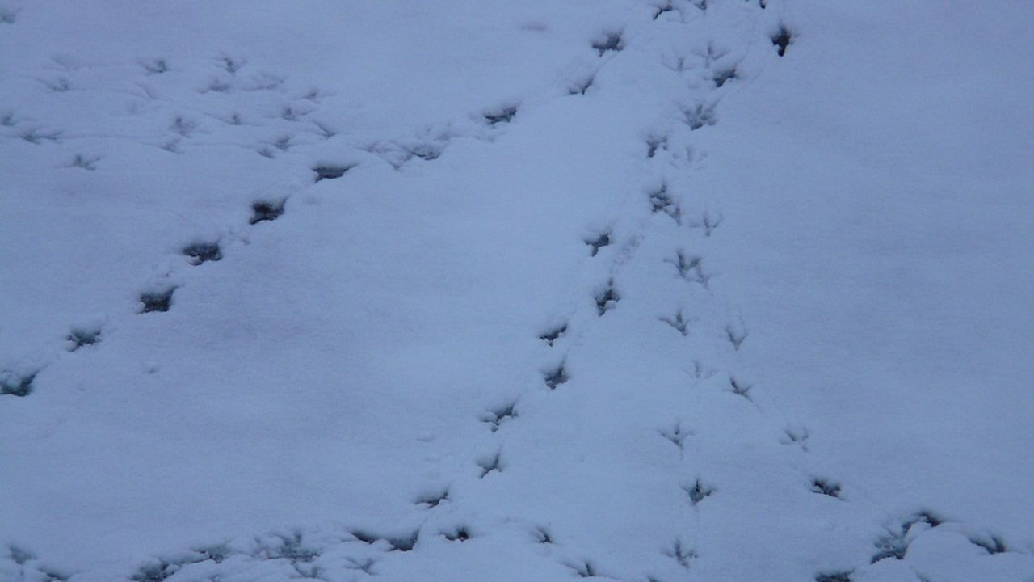
Footprint walks
Particularly good after snow – even a light covering! – when you go out, look for footprints in the snow or mud and try to find out what or who made them. Try to find as many different footprints as you can and either take photographs or draw the prints to identify when you get back home.
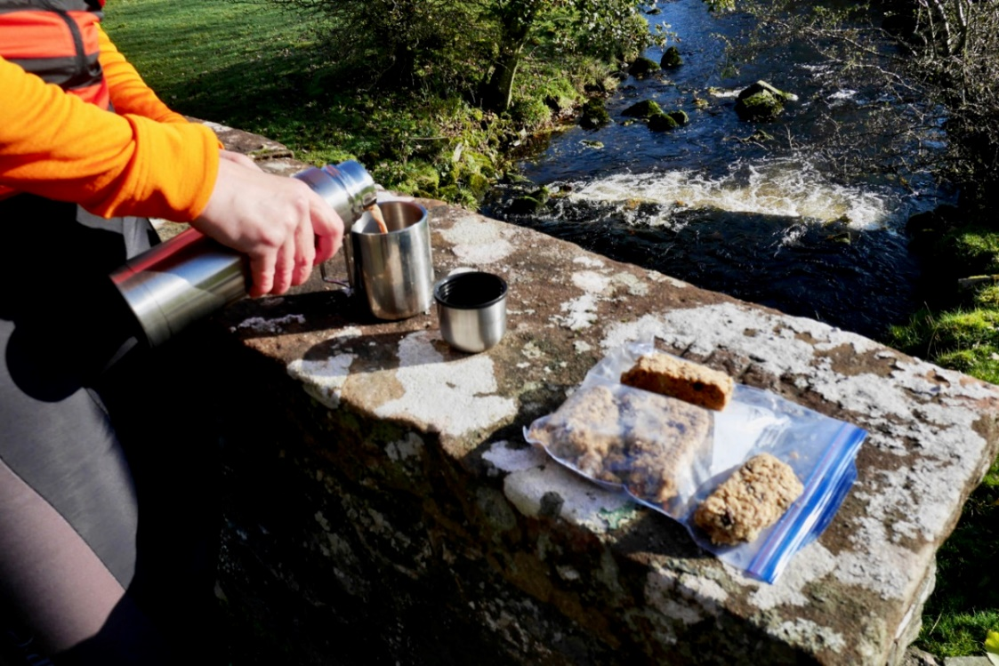
Winter picnics
Children love outdoor eating and drinking and picnics definitely aren’t just for summertime! Take a flask of hot drink, such as hot chocolate or even soup, or heat some squash for a warm fruity drink. The Woodland Trust has a lovely recipe for mulled apple juice – take a litre of apple juice or diluted squash and place in a pan with a cinnamon stick, three cloves and a few pieces of orange peel and heat gently for around 10 minutes. Strain and pour into a flask. Remember to take mini marshmallows for hot chocolate and a snack – the Trust suggests cooking chilli and putting in a food flask before decanting into pre-opened pitta pockets, cooking hot dog sausages at home and keeping hot in a food flask before placing in bread rolls outdoors or wrapping baked potatoes in foil and then covering in layers of tea towels and adding grated cheese and butter when you stop to eat.

