Cornflake Cakes

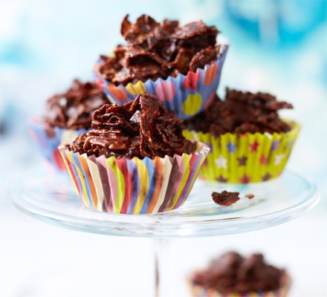

Ingredients;
- 50g butter
- 100g milk or dark chocolate, broken into chunks
- 3 tbsp golden syrup
- 100g cornflakes

Method;
- Weigh out the ingredients. Put 50g butter, 100g milk or dark chocolate, broken into chunks and 3 tbsp golden syrup in a saucepan or microwavable bowl. Put 100g cornflakes in another large bowl.
- Melt the weighed butter, chocolate and golden syrup in the saucepan over a low heat or briefly in the microwave.
- Allow to cool a little before pouring over the cornflakes.
- Stir the ingredients together gently using a wooden spoon.
- Spoon the mixture into 12 cupcake cases arranged on a muffin tray (or baking sheet, if you don’t have one).
- Put in the fridge to set.

