Bubble Wrap Printing
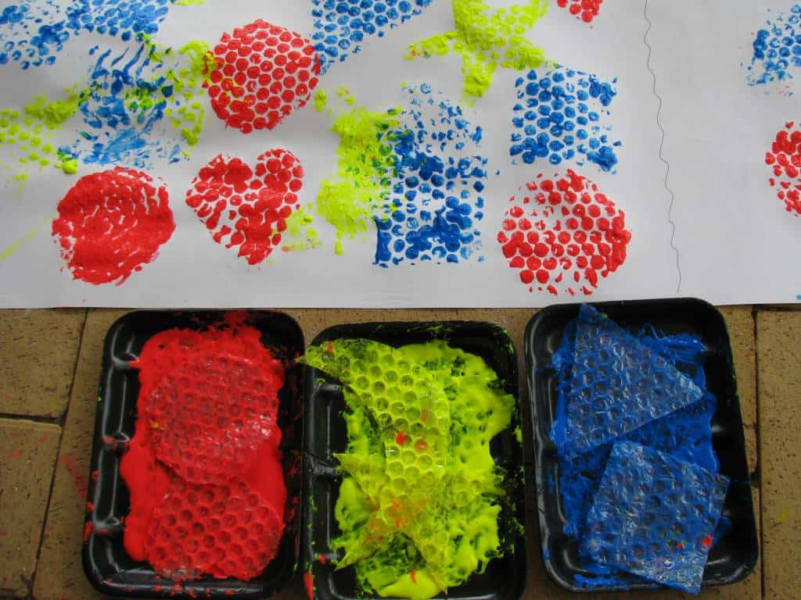
You will need;
*bubble wrap
*scissors
*paint
*trays or plates
*paper

Method;
- Cut shapes from the bubble wrap
- Pour paint onto the trays or plates
- Press the shapes into the paint (bumpy side down)
- Press the shapes on the paper
- Leave to dry

